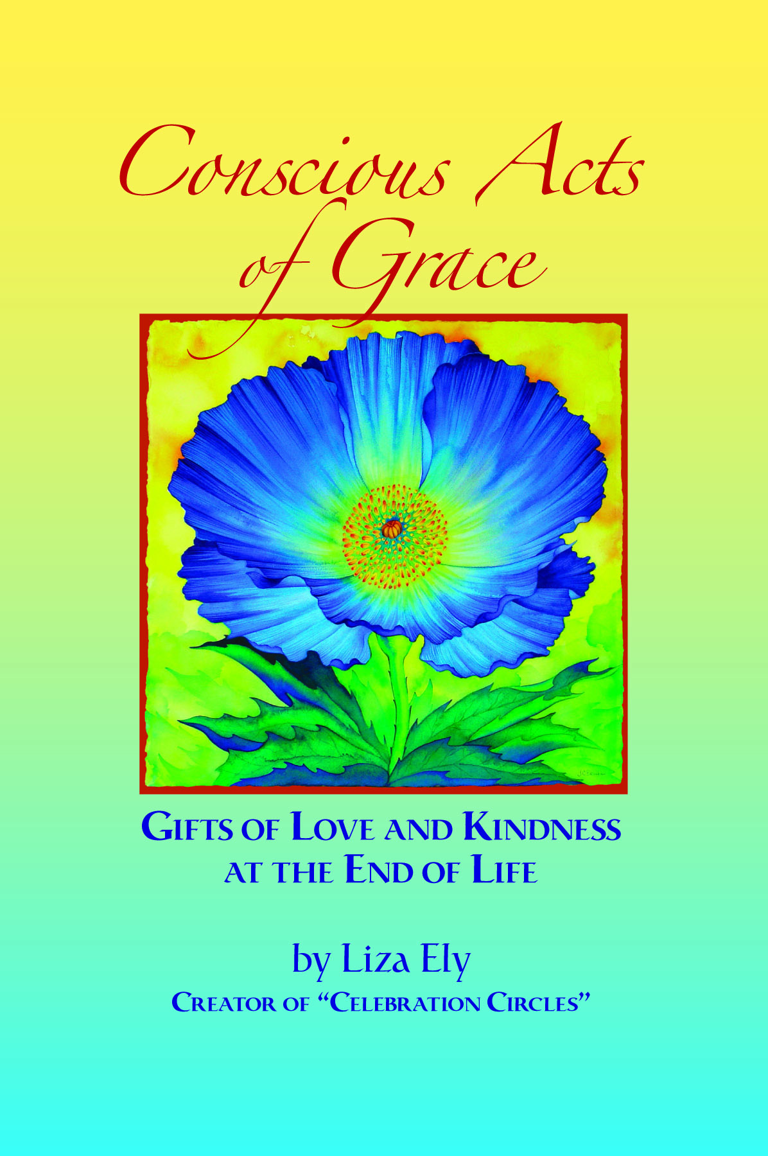
CONSCIOUS ACTS of Grace

A Workshop with Author,

Liza Ely

Our culture is poorly equipped to be with grief and dying. The pain, the anguish, the suffering of death can deep and invasive. Yet, other than birth, it is the one experience we all share.

There is another way. Conscious Acts of Grace are those words, actions, and touches that let our loved ones know we are there for them at the end of their physical life. With an opportunity to share with others and to experience peace and support, the following topics are explored: Listening, Support, Dignity, Faith, Letting Go, Forgiveness, Celebration Circles, and Then Some.

Based on her book, Conscious Acts of Grace – Gifts of Love and Kindness at the End of Live, Liza will offer you a roadmap of how to be with ourselves and our loved ones and how to hold the dying process in loving kindness.

YOU WILL:
๑ Explore questions to consider and how to open up discussions with others.
๑ Be given specific possible action steps.
๑ Experience a peaceful paradigm around the dying process.
๑ Learn how to create Celebration Circles for your loved ones

For more information about Liza’s book and message,
or to sign up for her Celebration Circle Action Groups or mailing list,
visit www.centerofwellbeing.com

